## Airtable offers the ability to create linked records, so rather than duplicating data across tables, you can link records between tables, creating a relational database structure.

## 

## Ease of Use

Air table is easy to use due to the following reasons:

It has a simple, clear and intuitive design: text and labels are not cluttering the interface.

The design remains fairly consistent throughout.

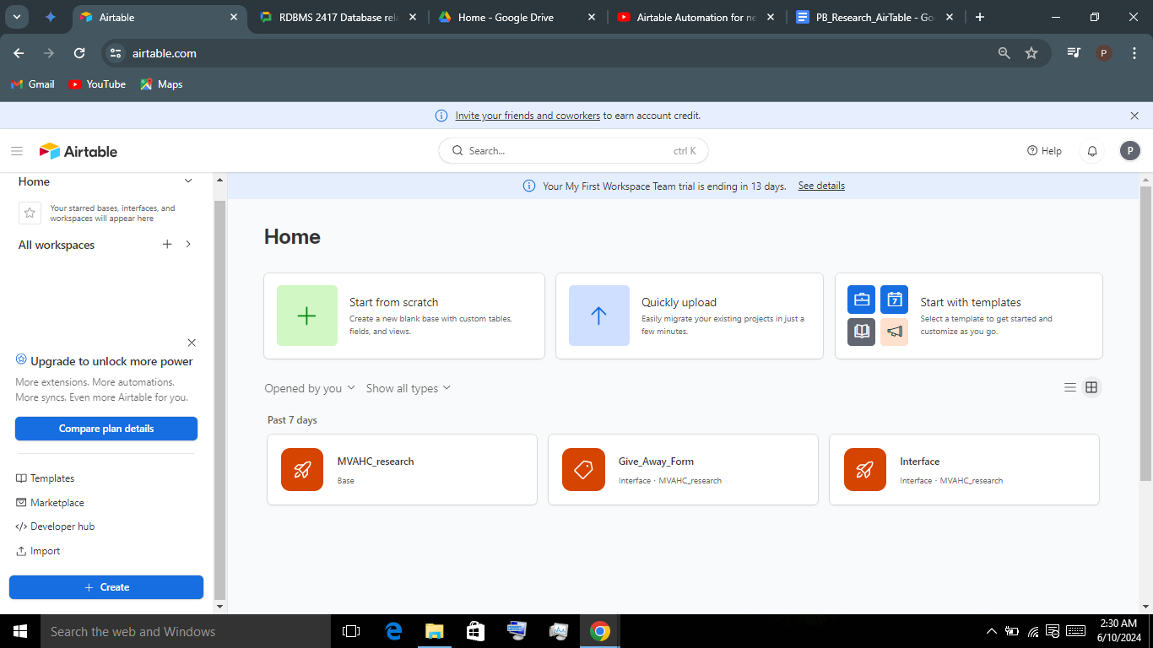

As you can see the buttons and labels are clear.

It is easy to predict how things work and therefore easy to learn.

Limited actions to complete tasks: for example, a click and a drag and drop to import a dataset.

Typing is limited and fields have clear labels indicating exactly what to type in a field with data validation enforced as well.(rejects the wrong datatype)

Most actions can be undone with Ctrl + z

Provides in context help

Offers a Getting Started Guide <https://www.airtable.com/guides/start/airtable-basics> , a documentation page <https://support.airtable.com/docs/introduction-to-airtable-basics> , <https://support.airtable.com/docs/airtable-training-and-resources> , and a youtube channel to help users along their learning curve besides all the third party resources.

It also offers search and filtering features.

Offers automation in security and ways to leverage automation in back-up to other cloud storage services through APIs.

## Ease of Back-up

Backing up in airtable is not an in-built feature yet there are a couple of easy ways to leverage this functionality like :

1. Manual back-up by exporting the data which is a very simple and easy process in airtable.
2. Connect the database to a cloud storage and use the automation feature in airtable to automate backing up to that cloud storage.
3. Used advanced API and script development to manage backup to third party storage locations.

I believe especially that the first two options can be easily and quickly set-up and managed to meet the backup needs of the MVAHC system.

The downside I believe is that recovery must be done manually or at least manually automated, ie, there is no in-built recovery in airtable despite the feature to be able to restore from trash within 30 days and other handy record recovery features.

So in essence there is no one stop one click button to restore but one can be created.

## Ease of Maintenance

The interface design of Airtable, its intuitiveness; pre-built templates and customizable blocks, automation, and permission and sharing (allowing for granular permissions control) make it very easy to maintain; but the complexity of maintenance in Airtable is dependent on the processes and workflows and automations one has built with it: complexity of database, heavy use of formulas, data volume, and the number of external integrations.

In essence, the ease of maintenance in airtable can be controlled by the user based on the design of their workflows and processes in airtable especially when they follow the guidelines for maintaining airtable base (simplification, documentation, regular reviews, standardization and version control).

## Cost (5000 usd/year)

Airtable offers a tiered pricing structure with different plans catering to individual and team needs. Here's a breakdown of the plans and their costs (as of June 10, 2024):

**Free Plan:**

* Ideal for personal use or trying out Airtable.
* Limitations:
  + 1,000 records per base (table)
  + 5 collaborators (editors)
  + 50 commenters
  + 1 GB attachment space per base
  + No synced tables (linking data across tables)
  + No synced integrations (connecting Airtable to other apps)
  + 1,000 API calls per workspace (limited automation)

**Plus Plan:** ($20 per user/month billed annually)

* Suitable for small teams or individual power users.
* Includes everything in the Free plan, plus:
  + 50,000 records per base
  + 10 GB attachment space per base
  + Unlimited editors and commenters
  + 10 synced tables
  + No synced integrations
  + 100,000 API calls per workspace

**Team Plan:** ($24 per user/month billed monthly, or $20 per user/month billed annually)

* Designed for teams needing collaboration and data sharing.
* Includes everything in the Plus plan, plus:
  + Unlimited bases
  + Synced integrations (connect Airtable to other tools)

**Enterprise Plan:** (Contact sales for pricing)

* Aimed at large organizations requiring advanced features and security.
* Includes everything in the Team plan, plus:
  + 500,000 records per base
  + 500,000 automation runs per month
  + Advanced security features (like audit logs)
  + Custom branding and priority support

**Choosing the Right Plan:**

The best plan for you depends on your needs. Consider factors like:

* **Number of users:** How many people will be collaborating in your workspace?
* **Data volume:** How much data do you anticipate storing in your bases?
* **Collaboration needs:** Do you require synced tables and integrations for data sharing and automation?
* **Security requirements:** Does your organization have specific security needs that require the Enterprise plan?

**Here are some resources to help you choose the right plan:**

* **Airtable Pricing Page:**<https://airtable.com/pricing>
* **Airtable Plans Compared:**<https://airtable.com/pricing>

## Mobile Accessibility

Can be used through a mobile web interface. Airtable also mobile accessibility focuses on touch interactions.

## Replicability

Replicability is not in-built in Airtable but can be easily achieved through similar concepts/ideas and implementations like were done with the macros in the excel MVAHC system besides using third party integrations and APIs like **Zap** (which automatically mirrors changes to backup):

Automations

Linking records and

Using formula fields

## Version Control

There are no built in version control features in Airtable yet it allows for integration with third party version control systems like Git to make up for it. This has a steep learning curve and requires technical expertise or at least a good familiarity with version control systems.

On the contrary, it is still very easy to do a manual back-up and restore or automate integration with Zappier or Integromat or Git to mirror changes in backup.

## Reporting

Interfaces in Airtable can function as a dedicated "reporting" module like in the traditional sense. It offers several functionalities that allow you to create insightful reports and analyze your data effectively, notably using the creating reports and dashboards with the “Interfaces” which can be shared and printed besides other functionalities like, filters and charts, roll up fields, formula fields and grouped views.

It's very easy and intuitive to build a report or a dashboard (and forms to populate your tables) based on your tables in the interfaces module; very user friendly.

Airtable can be integrated with third party reporting services like Zappier and be directly integrated and linked seamlessly with Tuitio, Metabase and Domo reporting tools.

## Security

Airtable emphasizes the security of their platform and takes steps to protect user data. Here's a breakdown of Airtable's security features and some additional considerations:

**Airtable's Security Measures:**

* **Data Encryption:** Airtable encrypts all user data at rest (stored on servers) using 256-bit AES encryption, a robust industry standard. Data is also encrypted in transit (between your device and Airtable's servers) using SSL/TLS.
* **Access Controls:** Airtable allows you to set granular permission levels for users and groups within your workspace. This restricts access to specific bases, tables, or fields, ensuring only authorized personnel can view or modify your data.
* **Audit Logs (Enterprise Plan):** For Enterprise plans, Airtable offers audit logs that provide a detailed record of user activity, including data access, modifications, and login attempts. This allows for enhanced monitoring and security analysis.
* **Regular Security Audits:** Airtable undergoes regular security audits by independent third-party security firms to identify and address any potential vulnerabilities.

## Support

Airtable offers the following support avenues to customers:

**Contacting Airtable Support:**

“Help” from the Airtable homepage at<https://www.airtable.com/>.

**Additional Resources:**

* **Airtable Help Center:** Airtable's Help Center offers a searchable collection of articles, tutorials, and guides on various Airtable functionalities. You can explore the Help Center section on the Airtable website by clicking "Help" and then selecting "Browse Help Articles".
* **Airtable Community Forum:**<https://community.airtable.com/>

Airtable's support team typically responds within 1-2 business days.

There are other aspects of Airtable support that I spoke about under ease of use on the first page of this document.

## Integration

Airtable offers a robust integration ecosystem that allows you to connect your Airtable data with various external tools and services. This integration functionality can significantly enhance the capabilities of your Airtable workspace. Here's a breakdown of Airtable's integration options:

**Types of Airtable Integrations:**

1. **Native Integrations:** Airtable offers built-in integrations with several popular tools. These integrations are directly supported by Airtable and require minimal setup. Examples include tools like:
   * Zapier: A versatile automation platform that allows you to connect Airtable with hundreds of other apps.
   * Slack: A communication platform where you can receive Airtable notifications and updates directly in your Slack channels.
   * **Google Drive**: Connect Airtable to Google Drive to attach files from your Drive to Airtable records.
2. **Partner Extensions:** These integrations are developed by Airtable's partners and offer specialized functionalities that complement specific use cases. Examples include:
   * DocuSign: Electronically sign documents directly within Airtable.
   * Typeform: Create and embed forms within Airtable to collect data.
   * Juro: Manage legal agreements and approvals seamlessly from Airtable.
3. **Airtable API (for Developers):** If you're comfortable with coding, Airtable's API allows you to build custom integrations with virtually any external tool or service. This offers maximum flexibility but requires programming expertise.

The integrations allowed in Airtable help improve its functionality in some of the criteria already discussed, like replicability and backup and restore, reporting, and version control.

## Customization

Airtable is highly customizable. It offers you a wide range of templates and allows for designing one’s own workflows, interfaces and automations to meet one's needs. Almost everything in airtable is customizable ranging from how granular one wishes to make the security and access controls, to integrations and interfaces.

Airtable is almost No-code, allowing for drag-and-drop in a guided intuitive user interface making it very easy to use. Support is available on youtube as well.

## Scalability

(Free: 1200 records, Plus: 5,000 records, Pro: 50,000 records, Enterprise: 500,000 records). These limits can become restrictive for very large datasets.

Airtable's scalability for handling large amounts of data and users has limitations, but it can be a great tool for personal use or smaller teams. Here's a breakdown of its strengths and weaknesses in scalability:

**Strengths:**

* **Suitable for Smaller Workspaces:** Airtable works well for managing projects, tasks, or databases with a moderate amount of data (ideally under 500,000 records per base).
* **Good for Individual Users or Small Teams:** Airtable's free plan and user-friendly interface make it a good option for personal use or small teams getting started with collaborative data management.

**Weaknesses:**

* **Record Limitations:** The record limit per base increases with paid plans (Free: 1200 records, Plus: 5,000 records, Pro: 50,000 records, Enterprise: 500,000 records). These limits can become restrictive for very large datasets.
* **Performance Impact:** Large bases with numerous records or complex formulas might experience performance slowdowns, especially on slower internet connections.
* **Limited Functionality for Scalability:** Airtable lacks features specifically designed for handling massive datasets or complex data pipelines that large enterprises often require.

**Alternatives for High Scalability Needs:**

* **Relational Databases:** For very large datasets and complex data relationships, consider relational databases like MySQL or PostgreSQL. These offer greater scalability and power but require more technical expertise to set up and manage.
* **Cloud-Based Data Warehouses:** If you need to analyze massive datasets and generate reports, cloud-based data warehouses like BigQuery or Snowflake can handle enormous data volumes and complex queries.

**Here are some additional factors to consider regarding Airtable's scalability:**

* **Base Complexity:** The complexity of your base (number of fields, formulas, automations) can also impact performance, especially for larger datasets.
* **Number of Users:** A large number of concurrent users accessing a complex base can strain Airtable's performance.
* **Airtable's Ongoing Development:** Airtable is constantly evolving, and they are gradually increasing record limits and improving performance. It's worth checking their updates for any scalability improvements.

**Overall, Airtable is a great tool for managing smaller datasets and collaborative workflows. However, it might not be the most suitable solution for very large datasets or highly complex data management needs that require significant scalability.** Carefully evaluate your data volume and user base to determine if Airtable can handle your needs

## Resilience

Airtable offers the following features to help one build resilience into one’s system:

**Airtable's Built-in Resilience Features:**

* **Version History:** Airtable automatically tracks changes made to your base, allowing you to revert to previous versions in case of accidental edits or data loss. This version history is available for free and paid plans, with a retention period of up to six months (depending on your plan).
* **Base Trash:** Deleted records and other base elements are not permanently removed immediately. They are placed in the base trash for a period of time (typically 7 days on free plans and longer on paid plans) allowing you to restore them if necessary.
* **Backup & Restore (Paid Plans Only):** Paid plans (Plus, Pro, and Enterprise) offer the ability to create manual backups of your entire base at a specific point in time. This backup can then be restored if needed.

**Additional Practices for Building Resilience:**

* **Regular Backups (Free Plans):** Even though free plans don't offer built-in backups, consider exporting your base data regularly (e.g., weekly or monthly) to a CSV file as a backup measure. This can be helpful in case of data loss beyond the version history timeframe.
* **User Permissions:** Set clear user permissions within your workspace to control who can create, edit, or delete data. This can help prevent accidental or unauthorized modifications.
* **Data Validation:** Utilize Airtable's data validation features to ensure data entered conforms to specific formats or criteria. This can help prevent errors and inconsistencies in your data.
* **Automation for Redundancy:** Consider using automations to create duplicate records or mirror specific data points in another table for redundancy. This can be a safeguard in case the primary data source encounters issues.

**Limitations of Airtable for Critical Data Management:**

* **Recovery Time Objective (RTO) and Recovery Point Objective (RPO):** While Airtable's version history and backups offer some level of data recovery, they might not meet the stringent RTO (how quickly data needs to be recovered) and RPO (how much data loss is acceptable) requirements for critical business data.
* **Disaster Recovery:** Airtable doesn't offer comprehensive disaster recovery features for large-scale events like hardware failures or natural disasters.
* **Data Security:** While Airtable offers security features like access controls and encryption, it's important to understand their security protocols and limitations. For highly sensitive data, additional security measures might be needed.

But a combination of Airtable with cloud storage backups is a very good resilience building solution because Airtable allows for seamless integration and hence exportation of data.